Identified Code Smells

* Simão Carrasco 59208:
  + Code Smell 1 – Duplicated Code:
    - Illustrating code snippet:

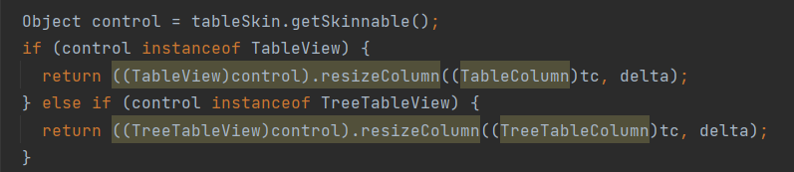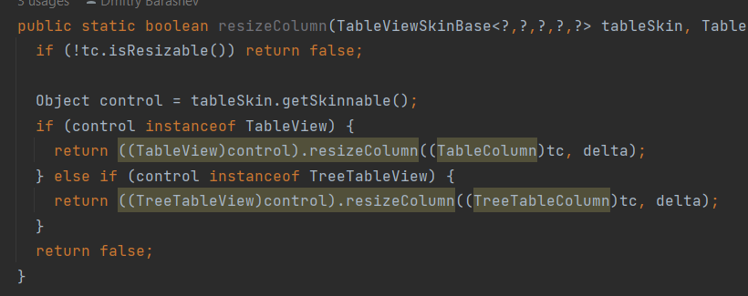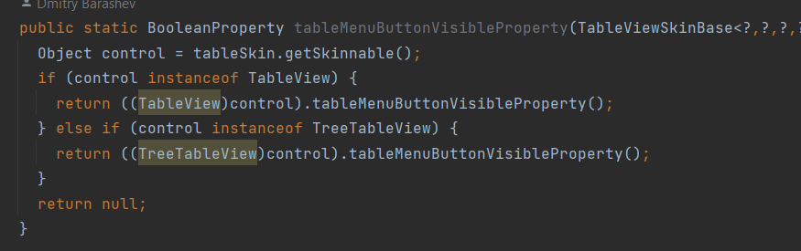

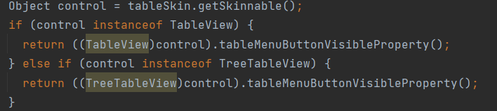

* + - The exact location on the codebase: ganttproject\ganttproject\src\main\java\biz\ganttproject\lib\fx\treetable\TableSkinUtils.java
    - An explanation of the rationale for identifying this code smell: Very similar chunks of code, with not a lot of diferences, wich are repeated multiple times across the class.
    - A refactoring proposal: Create a new function that returns the refered chunk of code, and the arguments of this new functon could be used to implement the small changes between de diferent implementations across the class.
  + Code Smell 2 - Data Clump:
    - Illustrating code snippet:



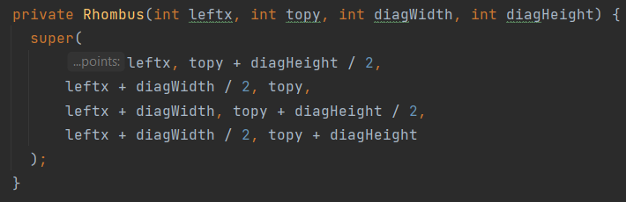

* + - The exact location on the codebase: ganttproject\biz.ganttproject.core\src\main\java\biz\ganttproject\core\chart\canvas\Canvas.java
    - An explanation of the rationale for identifying this code smell: The same pair of arguments is used multiple times across the class
    - A refactoring proposal: Create a new object that encompasses this pair or primitives
  + Code Smell 3 - Long method:
    - Illustrating code snippet:

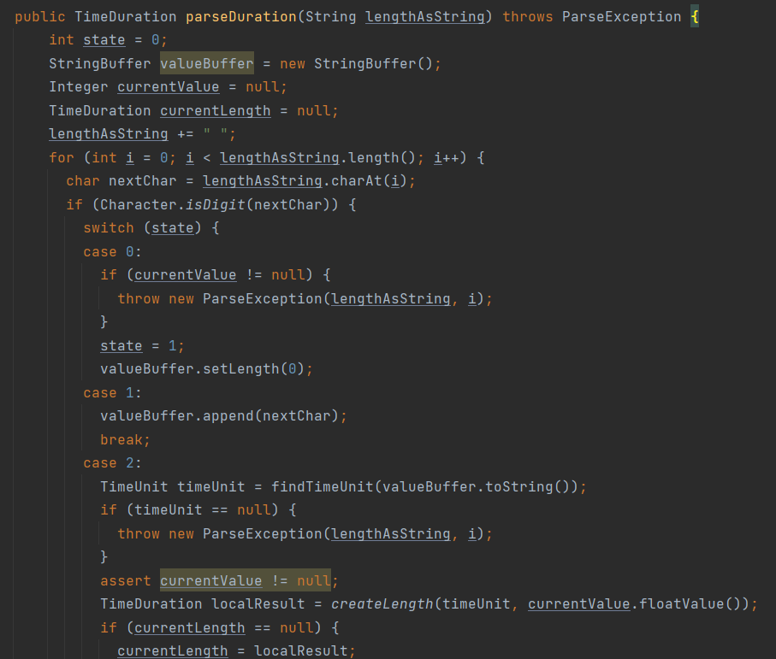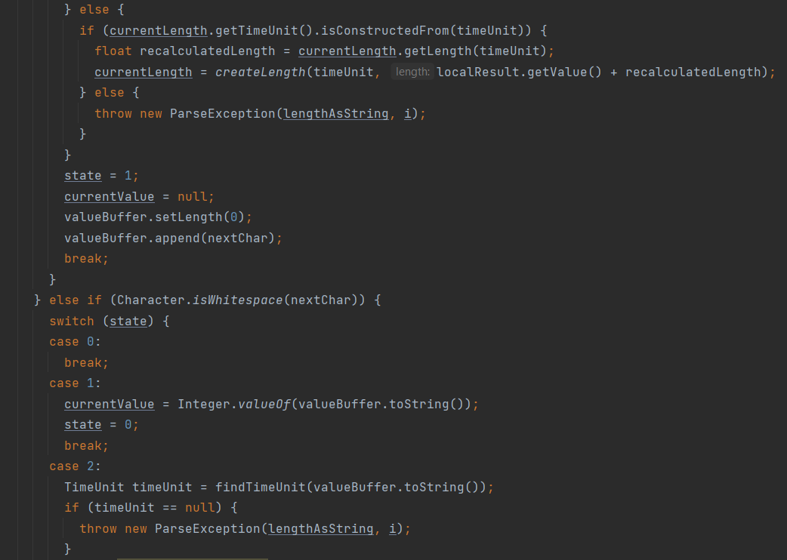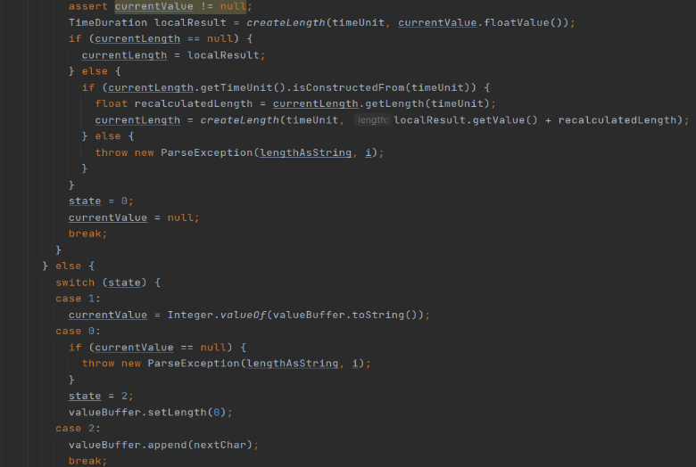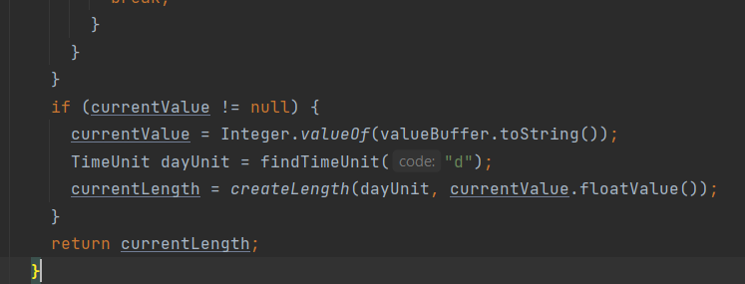

* + - The exact location on the codebase: ganttproject\biz.ganttproject.core\src\main\java\biz\ganttproject\core\time\impl\GPTimeUnitStack.java
    - An explanation of the rationale for identifying this code smell: Really long method, sugesting that some of it’s functionalities should be dispersed across diferent methods.
    - A refactoring proposal: Divide the code across new methods, and by doing this increasing the legibility and structure of the code.